**Creating a EC2 Linux Server**

**To launch an EC2 instance**

1. Sign in to the AWS Management Console and open the Amazon EC2 console at using your Administrator account. Make sure you’re in the **N. Virginia** region.
2. Choose **EC2 Dashboard**, and then choose **Launch instance**, as shown following.


                                EC2 Dashboard
                            

1. Name the Instance ***yourlastname*-LinuxSvr1**.   
   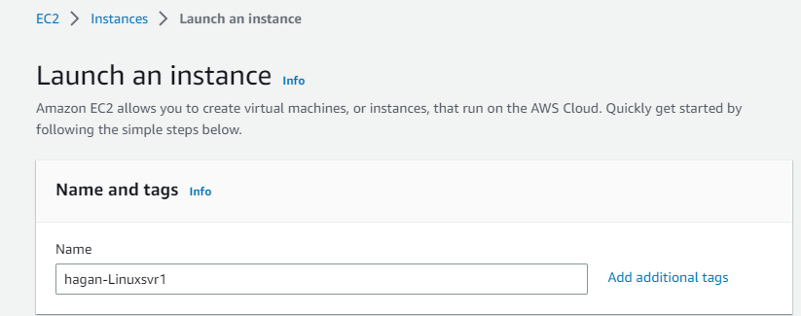
2. Choose the **Amazon Linux 2 AMI**. It should be the first one.

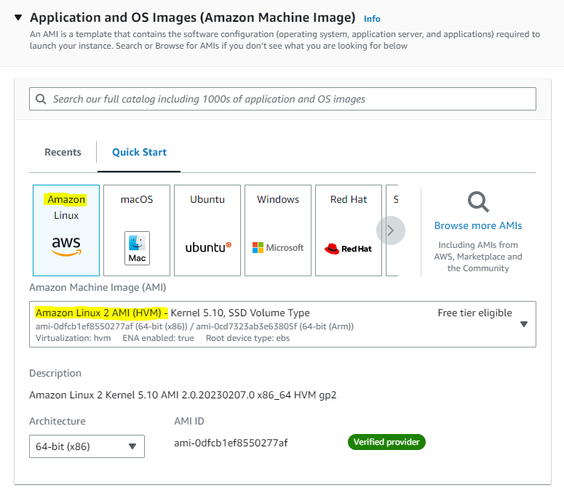

1. Choose the **t2.micro** instance type, which should be default.

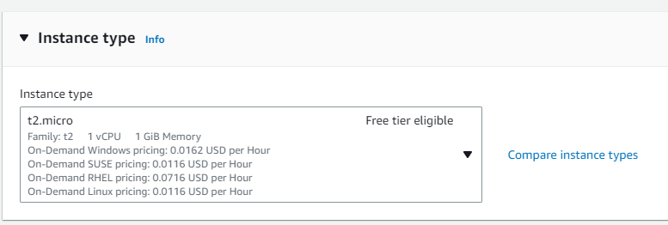

1. For Key pair, click **Create new key pair**. Name the keypair ***yourlastname*-Linux-key** and select **RSA** and **.ppk** (select **.pem** if you are on a MAC or non-Putty ssh client). Click **Create key pair** button and save file.  
   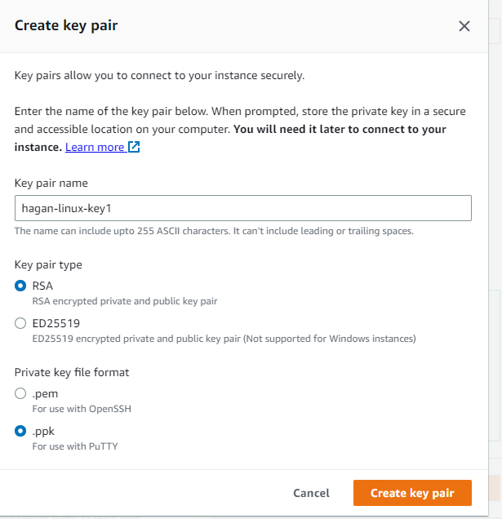
2. On the **Network settings** page, click the **Edit** button, set these values and keep the other values as their defaults:
   * **VPC:** Default.
   * **Subnet:** *No Preference*.
   * **Auto-assign Public IP:** Enable
   * **Select Create security group:** name it ***yourlastname*-LinuxSvr-sg**
   * **Inbound security group rules:** Leave Defaults

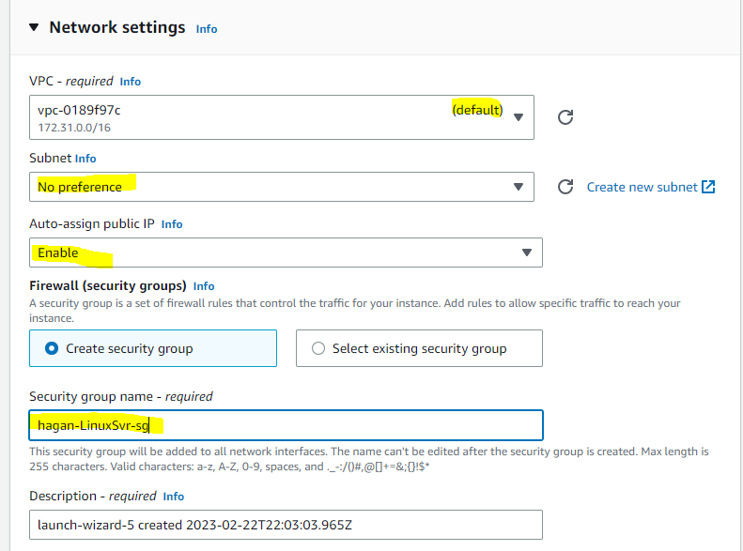

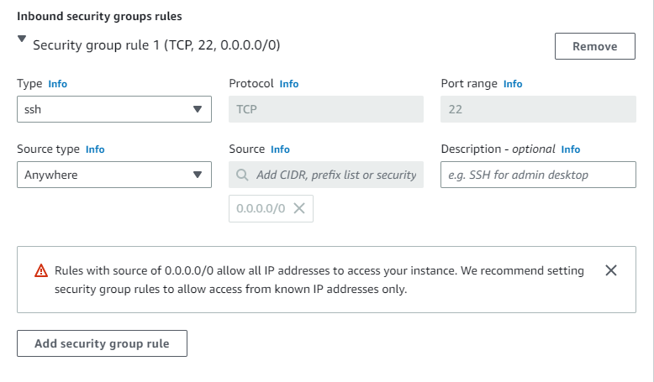

1. For **Configure storage,** leave defaults.
2. For **Advanced details,** leave defaults.
3. Click **Launch Instance**.
4. Click **View Instances** to find your new instance.
5. Wait until **Instance Status** for your instance reads as **Running** and health checks passed before continuing. **Screenshot this and paste to a Word Doc called *EC2-Linux.docx* under heading of Screenshot1**.

**Connecting to Instance using Putty**.

Next, you connect to your EC2 instance.

**Downloading Putty Client (**if you don’t already have it). MAC users can jump to Step 14.

1) On your Windows host, download Putty from https://www.chiark.greenend.org.uk/~sgtatham/putty/latest.html

2) Selection under ***Package file*** the 64-bit version for Windows (the .MSI file). MAC user can select the .tar.gz .

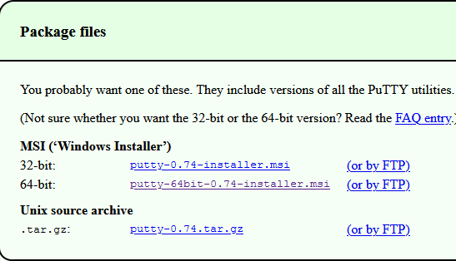

3) Save the download file to a directory of your choosing.

4) Locate the download file and run it.

5) At the Welcome screen, click **Next**.

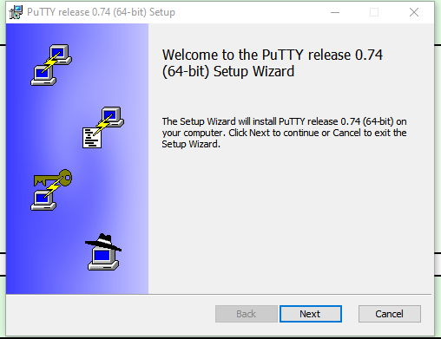

6) Select your install folder (can probably take the default here) and click **Next**.

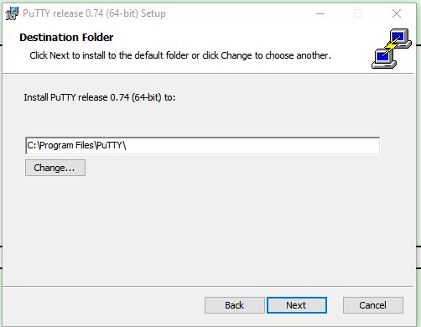

7) Hit **Install** on the ***Product Features*** screen.

8) Uncheck the ***View Readme file*** and click **Finish**.

9) If you saved your keypair as a .pem, open puttygen by typing ***puttygen*** in the Windows searchbox. If you save keypair as .ppk, jump to Step 13

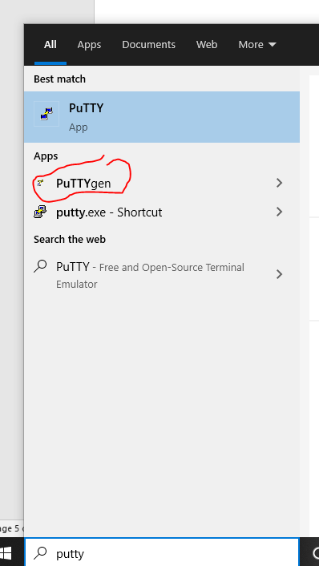

10) Click the Load button and search for the .pem file you downloaded for the linux server. Putty doesn’t understand .pem format so we have to convert to a .ppk file. (Change the file type to **All files *.\***)

11) Find the linuxsvr1 .pem file you downloaded when you created your instance.

12) Once loaded, click the **Save Private Key** button and save it as ***yourlastname-linuxsvr1-privkey.ppk.*** You will use this in Putty to login to you EC2 instance without a password. Close puttygen

13) Open Putty (use searchbox in Windows)

14) For the *Host name or IP address* in Putty, go to you AWS console to the linuxsvr1 EC2 and check the checkbox. In the lower pane under **Details**, **capture the screen with both the Public and Private IP Address and paste to a Word Doc under heading of Screenshot2.** (MAC users can jump to Step 20 after getting the Screenshot)

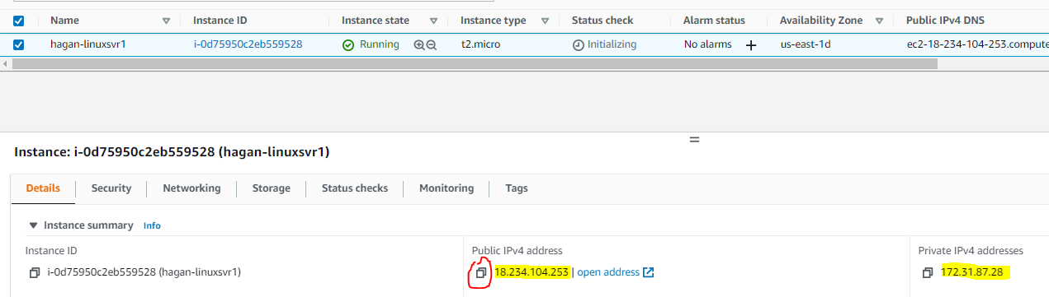

Find the Copy icon next to *Public IP Address* and click it. Paste that into your Putty window.

15) In the *Saved Sessions* field, type ***yourlastname-linuxsvr1*** and click the **Save** button on the right.

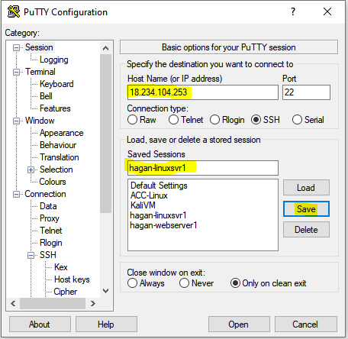

16) Now we need to add the Private key. In the left Putty pane, under **Connection**, expand **SSH** and select **Auth**.

17) Under *Private key file for authentication*, click **Browse**.

18) Locate your private key linuxsvr1 .ppk file (the one created in step 12), select it and click **Open**.

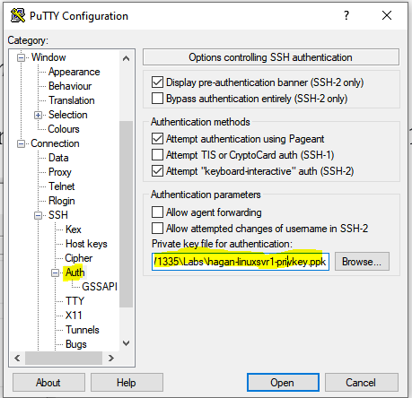

19) In the Putty Window left pane, go up to **Session** then click the **Save** button again. This will now also save your private key in the client profile.

20) Click **Open** to start your session. On the Putty Security Alert pop-up, select **Yes**. Once it connects, type ***ec2-user*** for the username. No password is necessary. If you can’t connect, go back to the AWS console and make sure the instance is up and health checks passed. For **MAC** **users**, open a Terminal window and type **ssh -i /path/to/privatekey ec2-user@*LinuxSvrIPAddressfromStep14*** (if your key is in the same directory you run the command from, you don’t need to specify a path).

Run the following commands to update the install.

**sudo yum update -y**

**Screenshot this and paste to a Word Doc under heading of Screenshot3**.

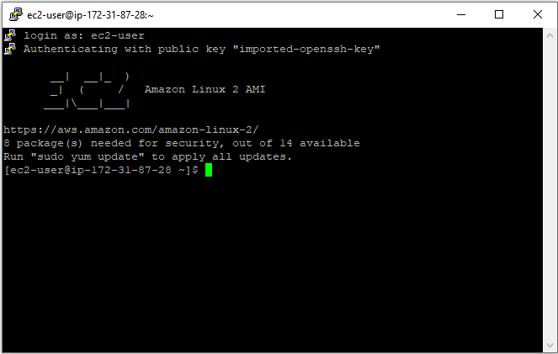

**Wrap Up**

1) Stop your EC2 instance by typing **sudo poweroff** in the Putty session. Then go back to the AWS Console and terminate the Instance.

2) Go to the AWS console under EC2 Dashboard and make sure your instances have stopped. You may need to refresh a few times. If it doesn’t stop after some time, check the box next to the instance, go up to the **Instance State** dropdown and select **Stop Instance**.

3) Logout of AWS

4) Upload your Word *EC2-Linux* Doc to Blackboard.